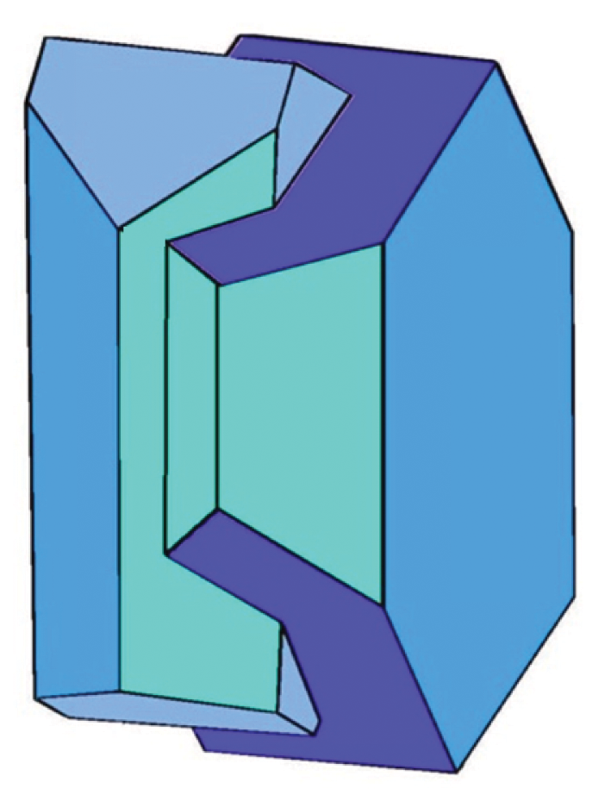
Nomination form for Mineralogical Society Awards
Collins Medal

'The Collins Medal will be awarded annually to a scientist who, during a long and active career, has made an outstanding contribution to pure or applied aspects of Mineral Sciences and associated studies. Publications, teaching, outreach and other activities leading to the promotion of mineral sciences, in the broadest sense, will be taken into account in making the award. Nominees do not have to be Members of the Mineralogical Society or nationals of Great Britain and Ireland.'
Nominations should consist of a completed nomination form signed by the main nominator, a seconder (both nominator and seconder should be members of the Society) and up to two additional supporters (who do not have to be members of the Society) and a copy of the nominee’s CV.

Nominations will remain on the table for three years. Previous recipients of the award, Society Officers, members of Council and members of the Committee (at the time of nomination and adjudication) will not be eligible for the award.

Nominator
Name
Address
E-mail address
Signature

Seconder
Name
Address
E-mail address
Signature

Supporter-1
Name
Address
E-mail address
Signature

Supporter-2
Name
Address
E-mail address
Signature

Name of nominee
Address
E-mail address

Please attach an up-to-date copy of the nominee’s CV.

Nominator, please state why your candidate should be awarded the Collins medal. Outline his/her

Published contributions

Contributions to teaching/instruction

Contributions at conferences, workshops

Contributions and service to the mineralogical community

Contributions to the Mineralogical Society, if relevant

Other information

Other esteem indicators of the nominee

Feel free to continue on a separate sheet if necessary

Please suggest a meeting/venue at which the medal might be awarded.

Signed
Nominator: Seconder:

Supporter-1: Supporter-2:

 I certify that, to the best of my knowledge, the person I have nominated has not been sanctioned or found at fault as the result of a complaint, investigation, or other proceeding related to his/her professional conduct (including harassment allegations), and that he/she is not currently the subject of such an investigation
 I am aware that the person I have nominated has been sanctioned or found at fault as the result of a complaint, investigation, or other proceeding related to his/her professional conduct, or that he/she is currently the subject of such an investigation but would nevertheless like to proceed with the nomination. (Please note that selecting the second case is not necessarily disqualifying, but you may be contacted for a confidential discussion.)

